User Guide

Media Organiser

Contents

Installation/Setup 2

Pre-requisites 2

Setup 2

Application Usage Guide 2

Files 2

Upload Files 2

Viewing File Information 7

Update File Information 8

Delete File 10

Playlists 11

Create Playlists 11

Update Playlist Information 13

Manage Files in Playlist 14

Deleting Playlist 15

Categories 16

Create categories 16

Update category information 18

Delete category 18

State management 18

Saving current state 18

Loading previous state 18

# Installation/Setup

## Pre-requisites

In order to install the use this software, your system needs to meet the following requirements:

* **OS:** Windows 10 Home/Professional (x64)
* **Minimum Space:** 300MB
* **Minimum RAM:** 1GB
* Internet connection to download the software
* Unzipping Software (i.e. WinRAR, 7zip, etc)

## Setup

Assuming you’ve acquired the zip file containing the software, below are the steps you need to take to correctly setup the application on your system.

Before accessing the artefact, create a folder in your computer where you will be storing all the files of this software. This folder can be in any location which is at your convenience.

After creating the folder, you will have to unzip the application. You can use any unzipping software you wish. This example will show unzipping using WinRAR.

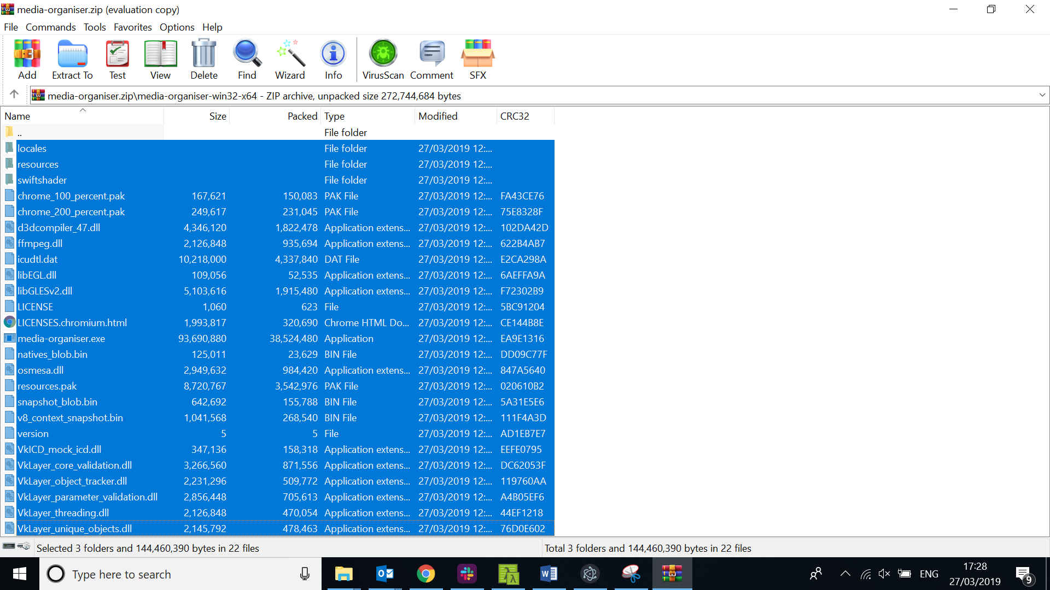

Select all the files from the ZIP file and extract them into the folder you created previously.

After all the files are extracted, this is how your folder should look like.

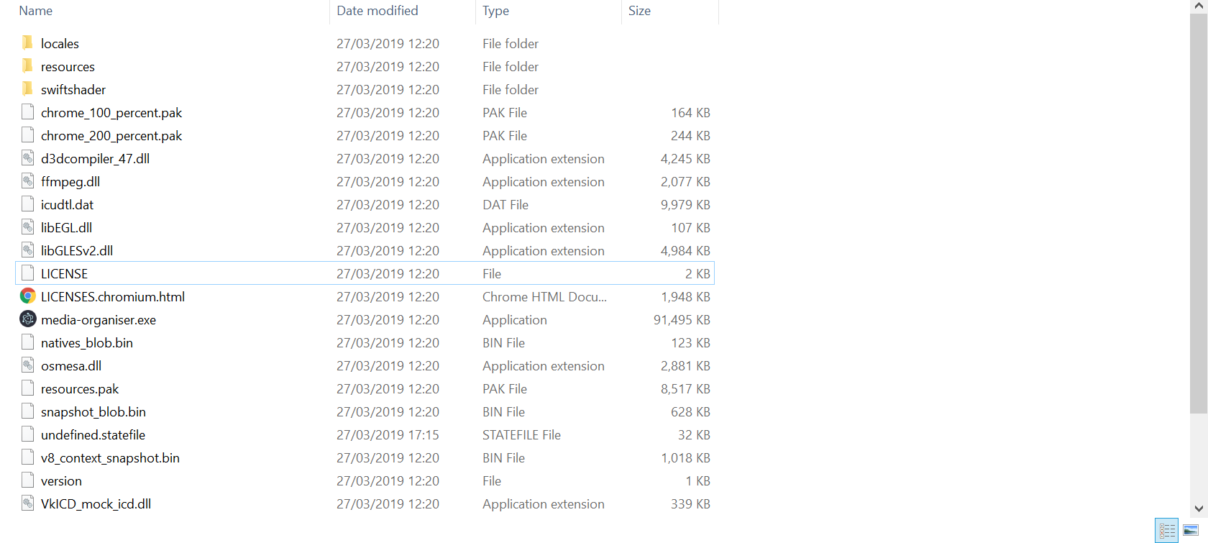

The last step is to start the application. To do that, **double click** or **launch** media-organiser.exe from the **same folder.** This should start the application.

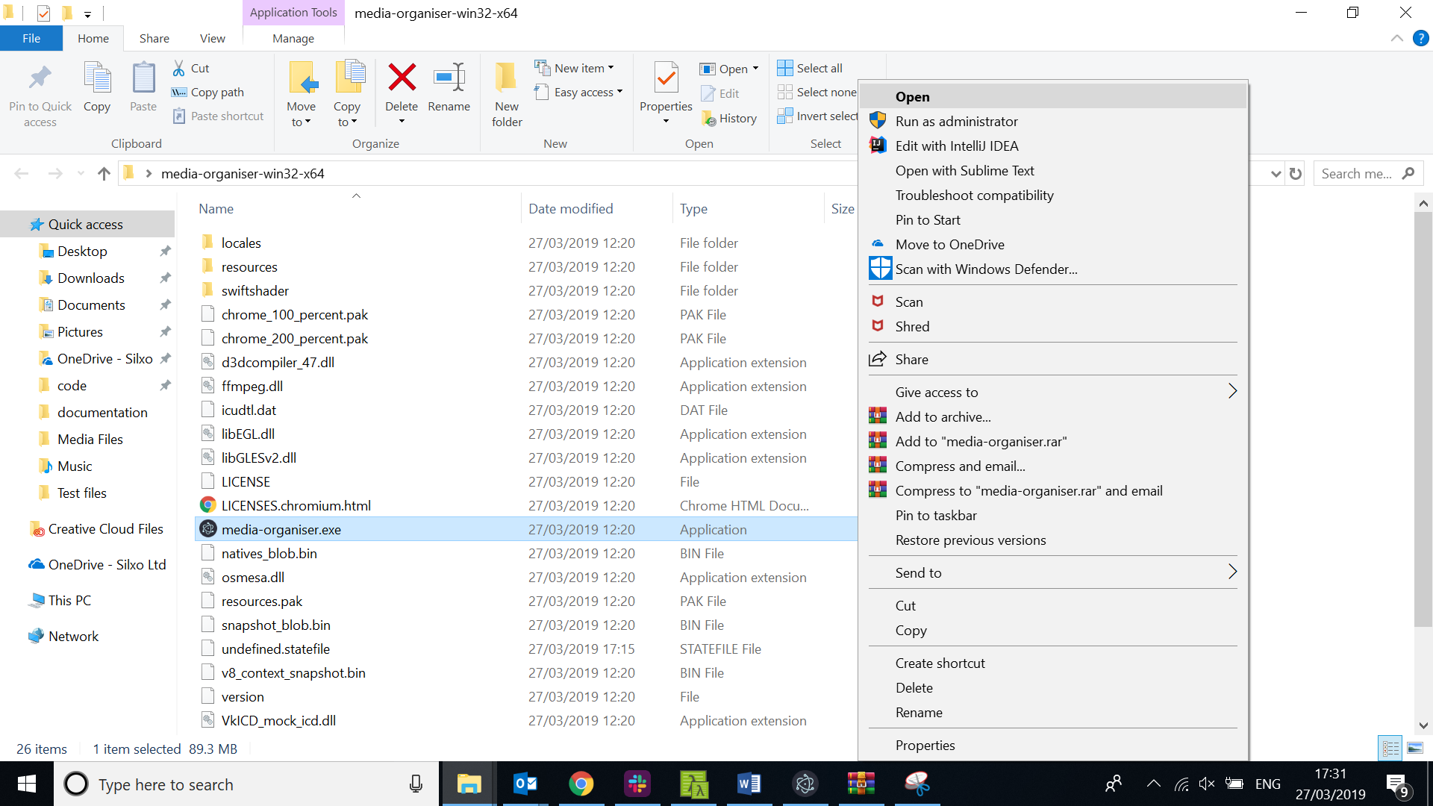

# Application Usage Guide

## Files

### Upload Files

Currently, there are two ways to upload files into the system. You can either select files from the system which you want to upload, or you can select a folder and let the application do the hard-work to find all the files with your selected extensions. Below are the steps you need to follow to add new files into the application

**Uploading Files**

In order to upload the file, first you will need to navigate to the files screen. This can be done by clicking on “Files” from the menu located on the left hand of the screen

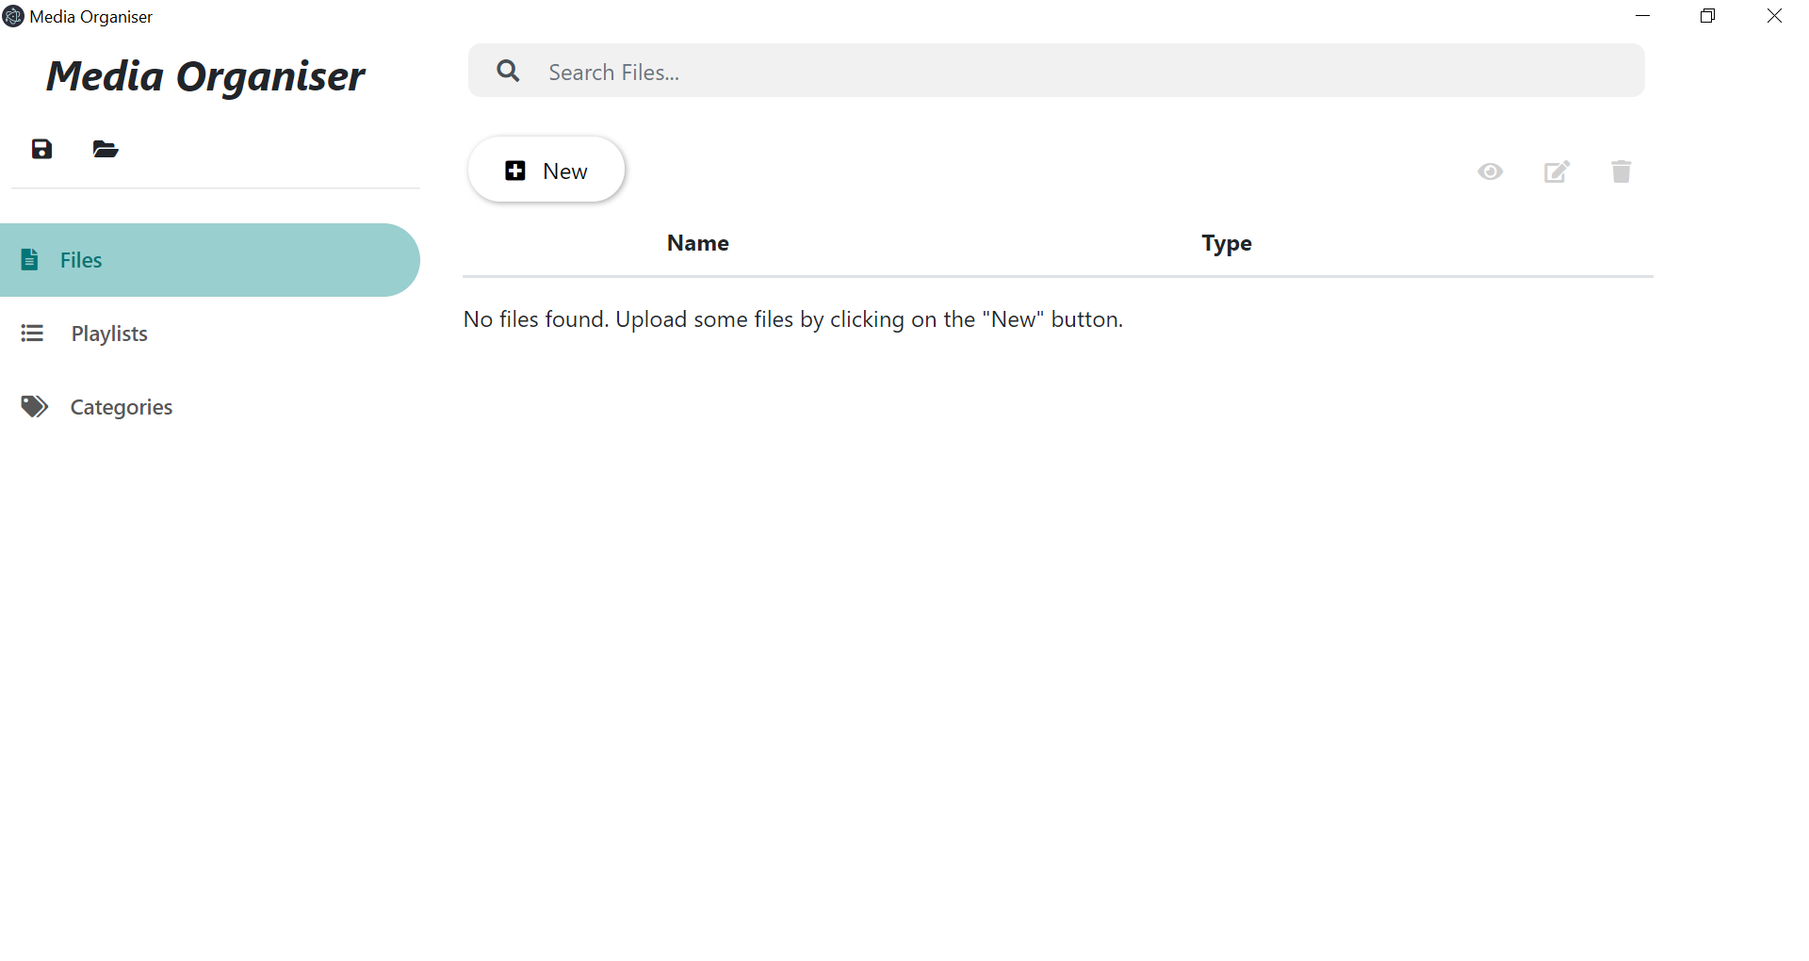

After you land on the “Files” screen, click on the big “New” button on the screen.

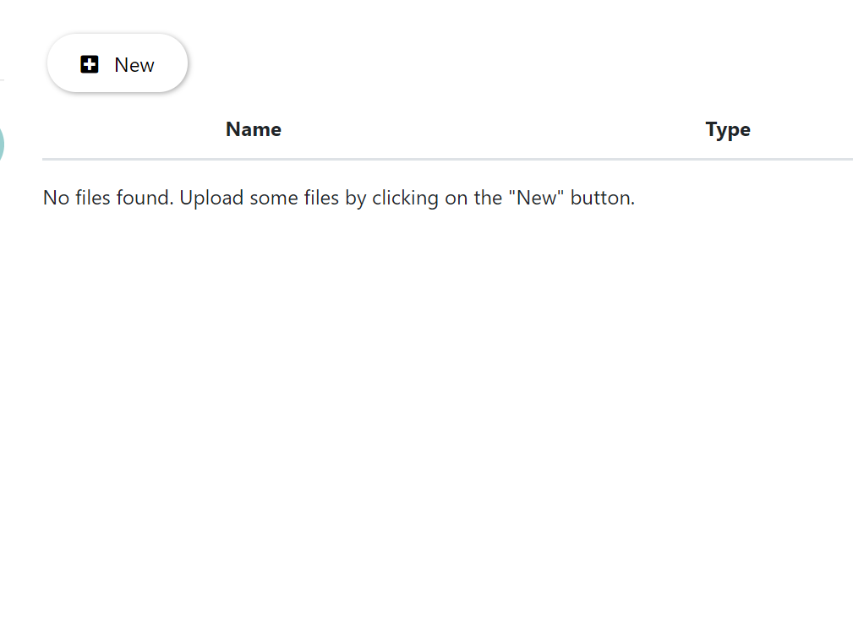

After clicking on “New”, you will be able to see 2 options which will let you choose how you want to upload the files. One will allow you to select files of your choice to upload and the other will allow you to select folders and scan all the files in that folder.

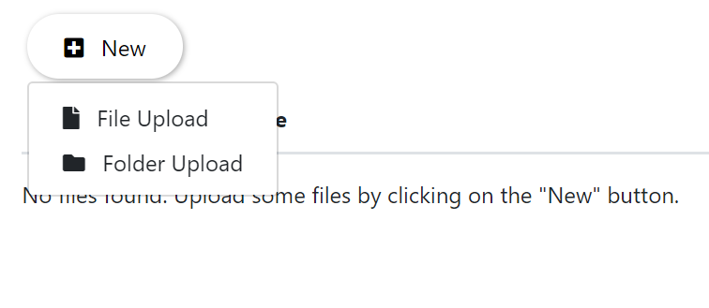

To be able to select multiple files of your own choice, click on “File Upload”. After clicking on file upload, a window will open which will give you some options before you start uploading the files.

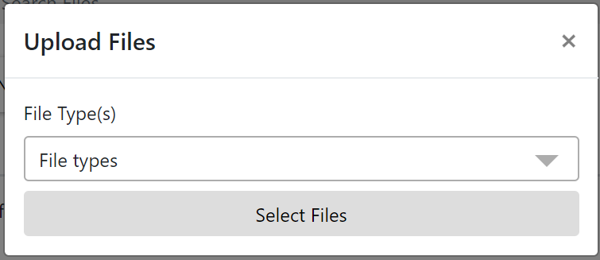

Before selecting the files, you will need to select which file types you will be uploading. To do that, click on “File types” dropdown. This will give you all the available options of supported file types.

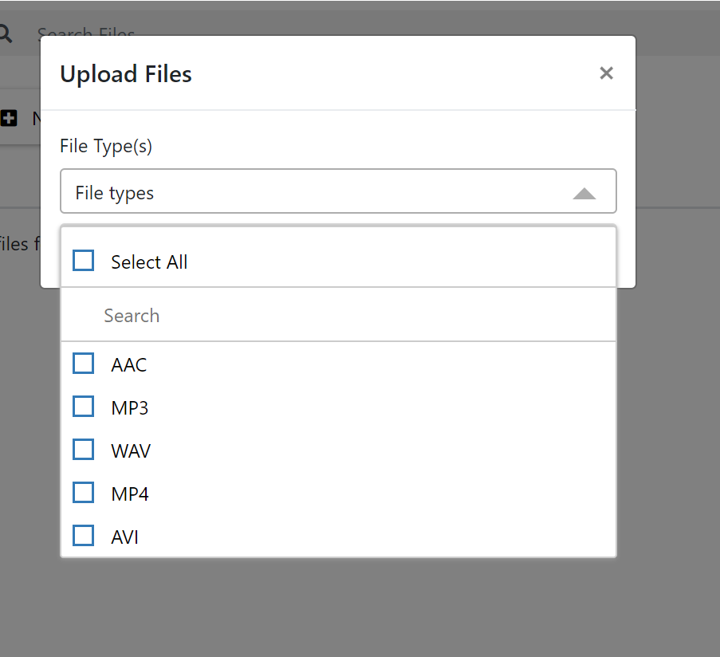

You can select any file type(s) you are willing to upload into the system.

After selecting the file types, click on “Select Files” button to have the ability to select files from your system.

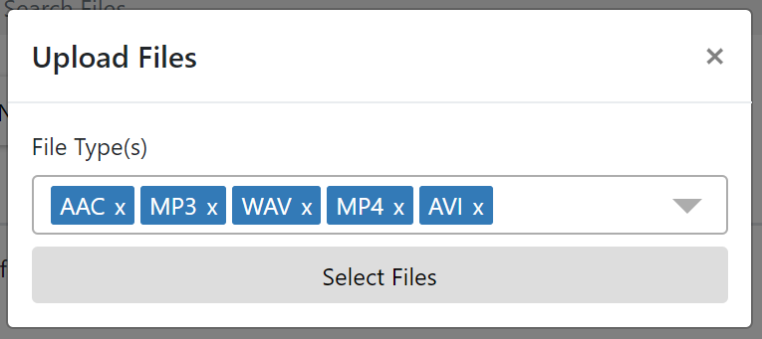

After clicking on the button, file explorer window will open which will display all the files in your computer.

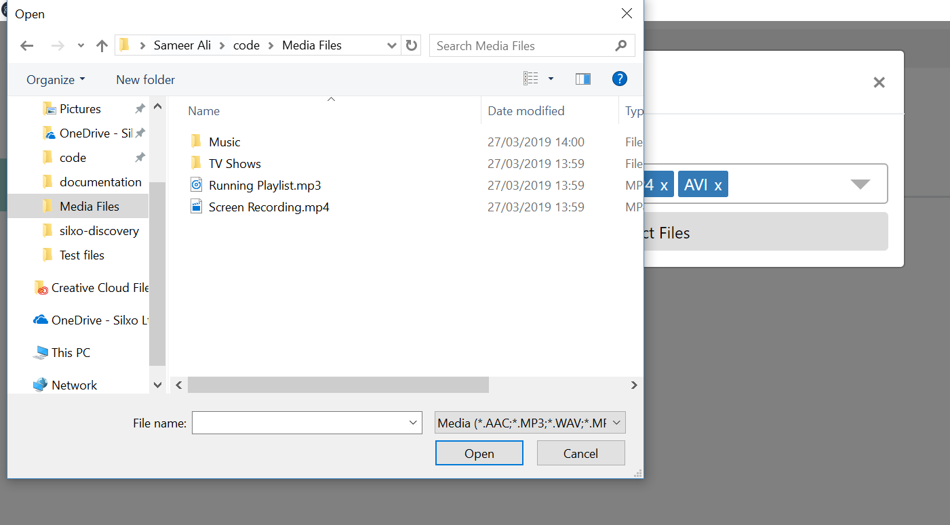

After selecting the files, click on “Open”. This will upload all the files you selected into the media organiser.

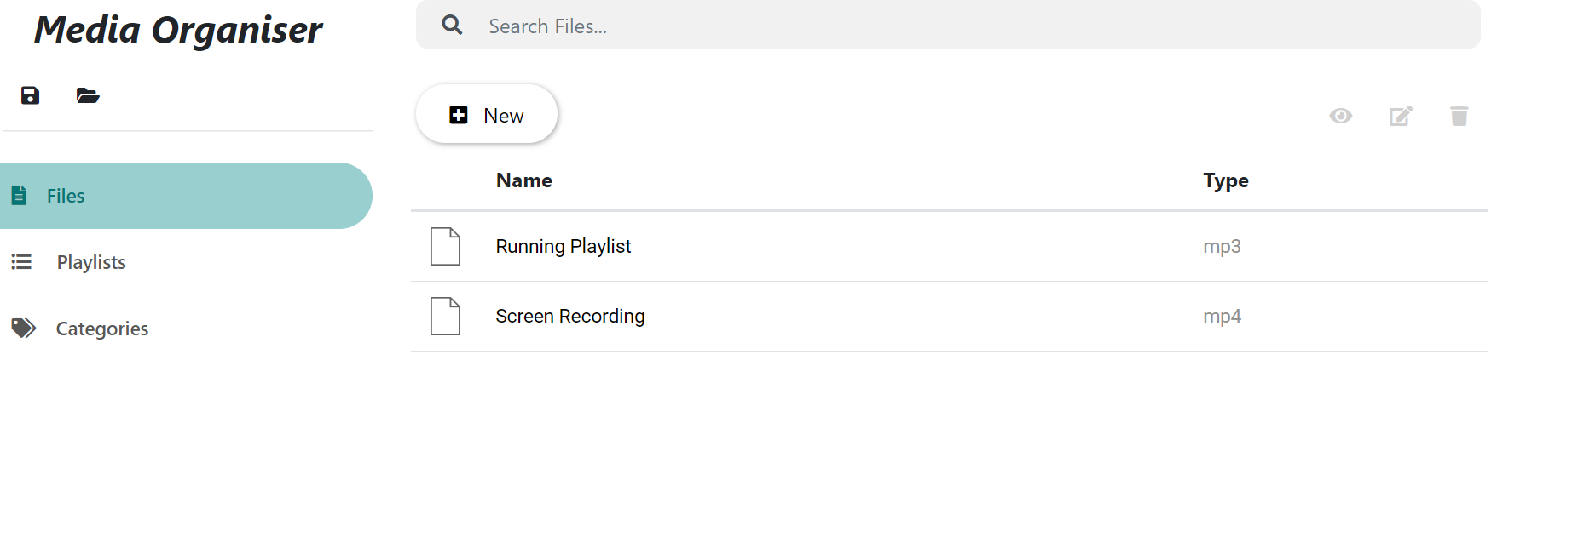

If you would like to select folder and let the application, select all the files. Click on new and select “Folder Upload” from the dropdown options.



This will give you the same options as above (selecting file types).

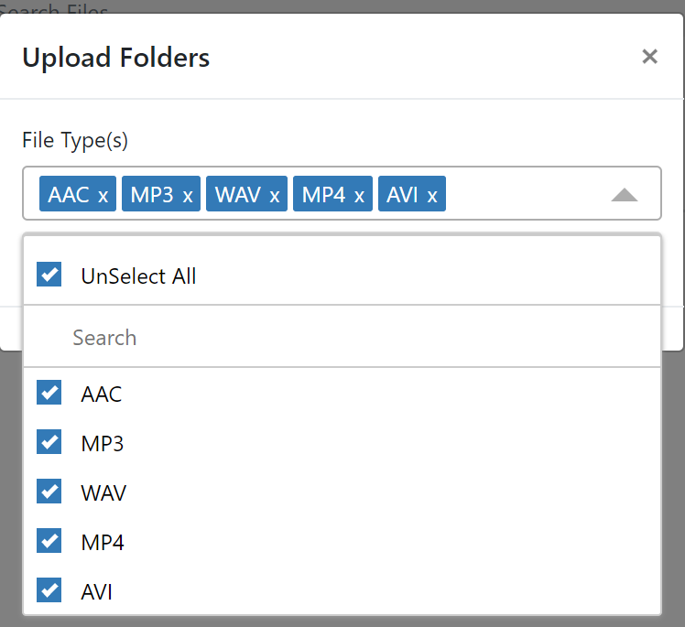

After selecting all the file type(s) you would like to upload, click on “Select Folder” button.

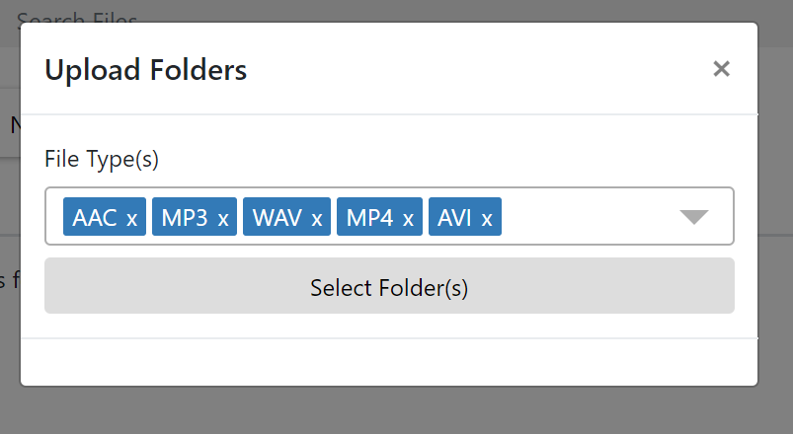

After clicking on this button, an explorer window will open which will allow you to select any folder you would like to read the files from. Please not that files **will not be shown**  in the explorer window as this option only allow directories to be uploaded.

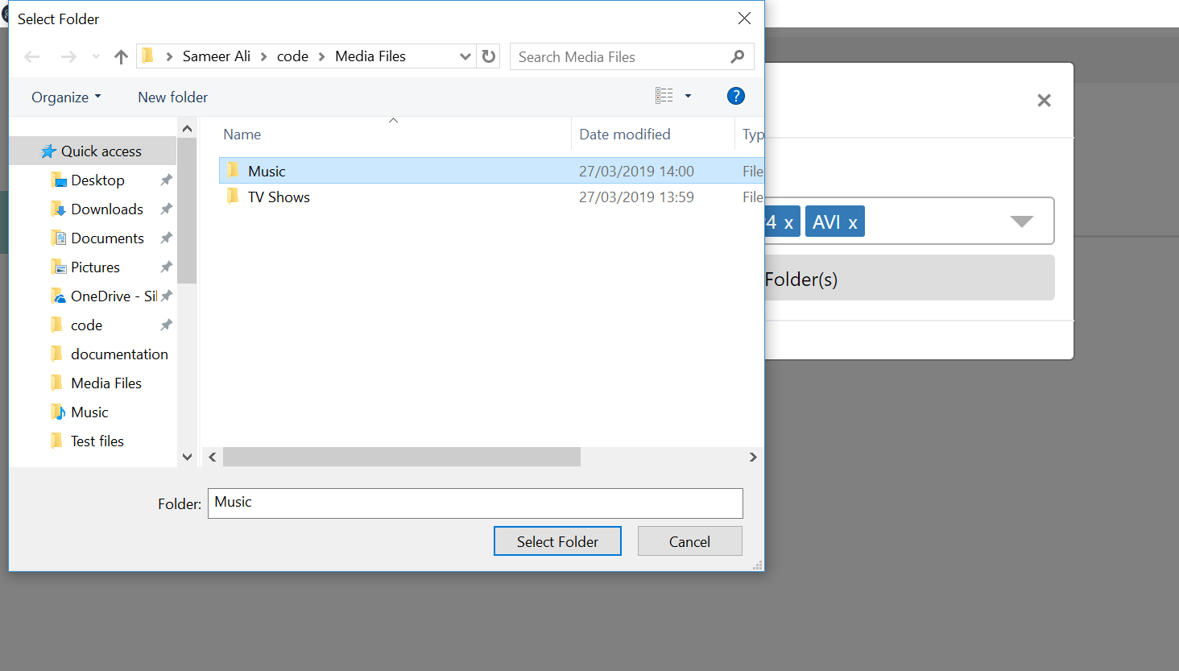

After selecting the folder, click on “Select Folder”. This will import the directory and extract all the supported files into the media organiser.

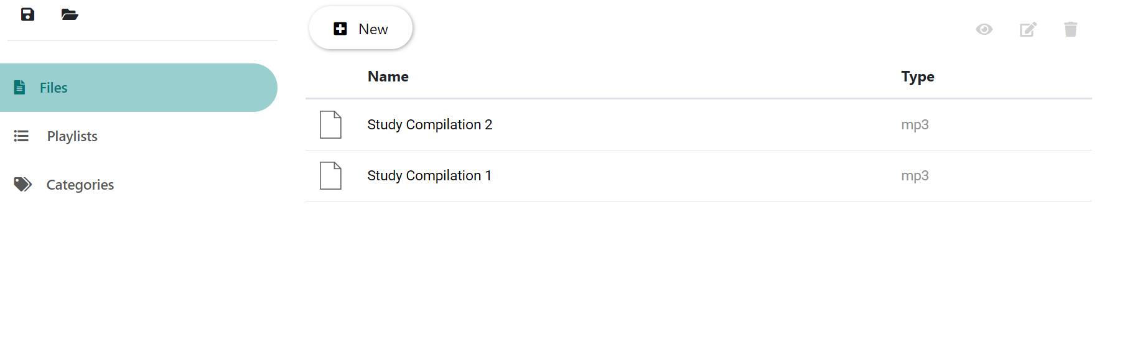

### Viewing File Information

To view the file information, go to the “Files” screen. This can be done by clicking on “Files” from the menu located on the left hand of the screen.

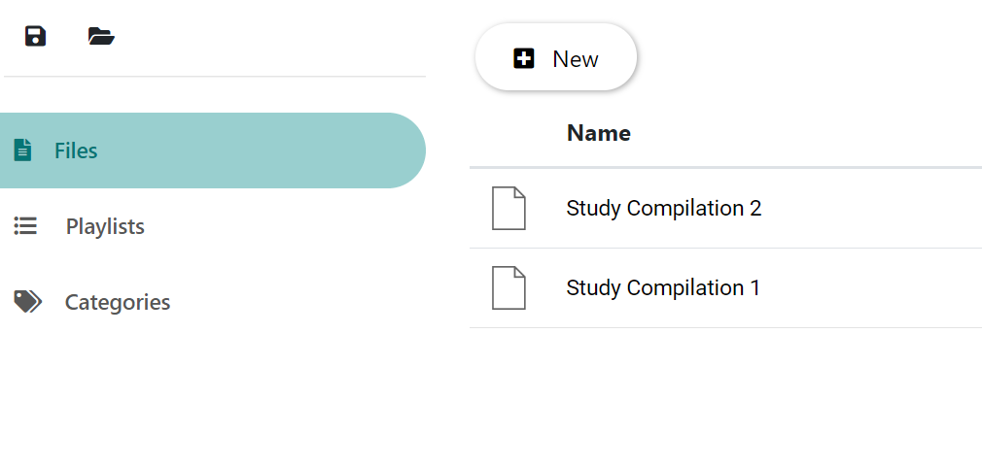

After going on the files screen, you will be able to see all the files that you’ve uploaded into the media organiser. To view information about any file, click on one of the files that you want to view the information about.

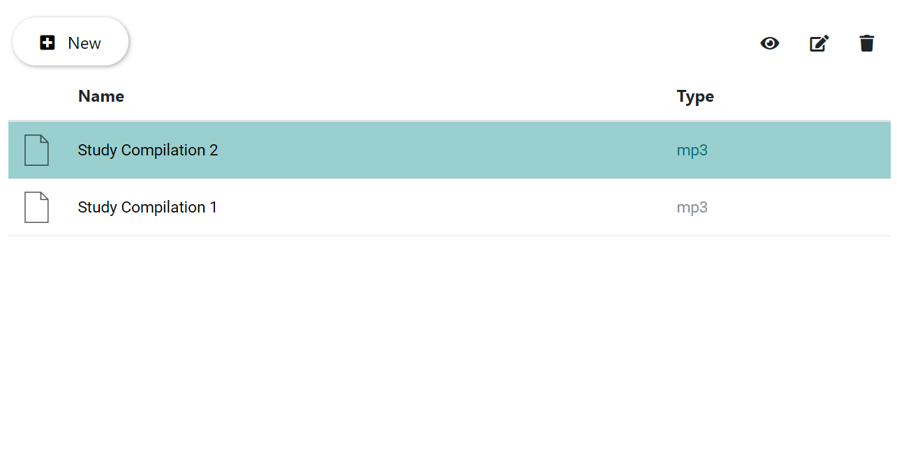

After clicking the on the file, you should see the file highlighted and the options located top right should get enabled. Click on the “eye” icon on the top right.

A window will popup on the screen which will display all the information about the file.

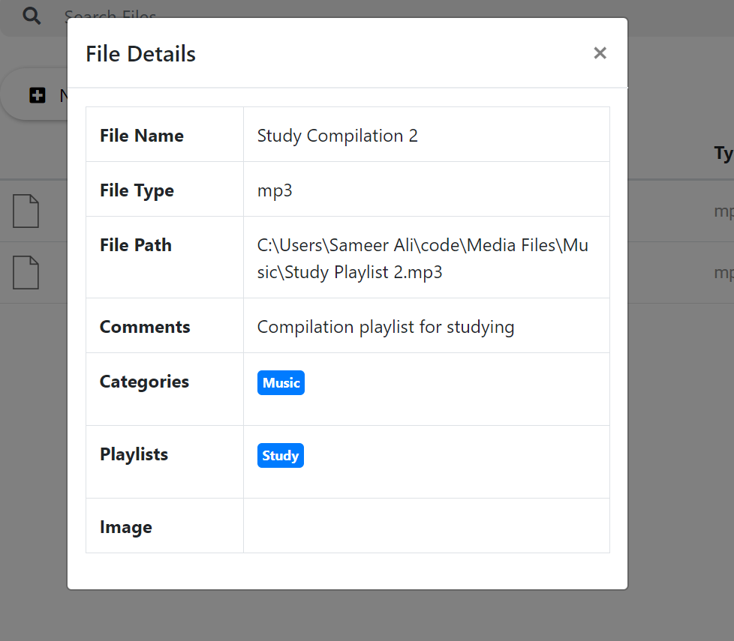

### Update File Information

To update the file information, go to the “Files” screen. This can be done by clicking on “Files” from the menu located on the left hand of the screen.



After going on the files screen, you will be able to see all the files that you’ve uploaded into the media organiser. To edit information about any file, click on one of the files that you want to edit the information about.



After clicking the on the file, you should see the file highlighted and the options located top right should get enabled. Click on the “pencil” icon on the top right.

A window should pop up on the screen showing you the file details and will also give you the ability to edit some of the details about the file (such as: filename, comments, playlists, categories and image).

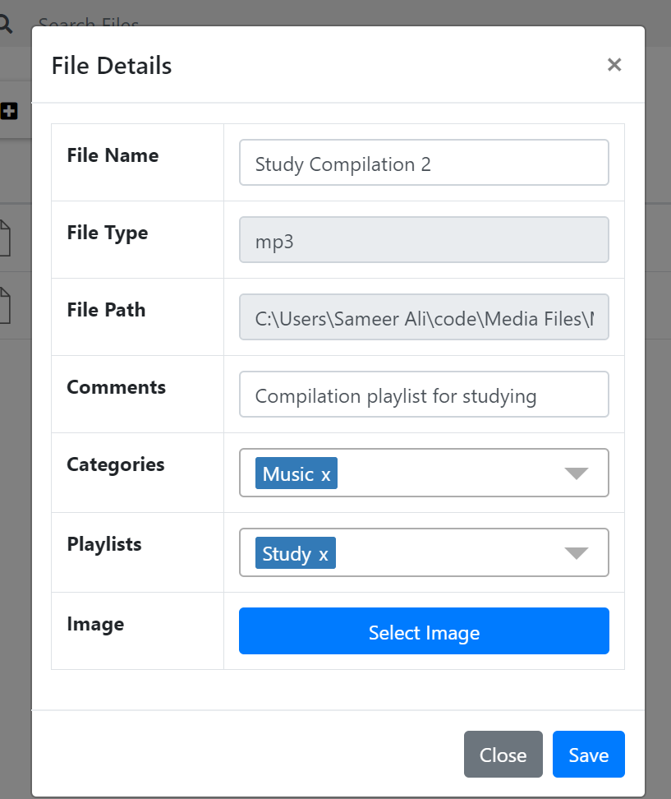

After editing all the details, click on the “Save” button to save all your changes.

### Delete File

To delete a file, go to the “Files” screen. This can be done by clicking on “Files” from the menu located on the left hand of the screen.



After going on the files screen, you will be able to see all the files that you’ve uploaded into the media organiser. To delete the file, click on one of the files that you want to view the information about.



After clicking the on the file, you should see the file highlighted and the options located top right should get enabled. Click on the “trash” icon on the top right. Clicking on that will immediately delete the file from the media organiser.

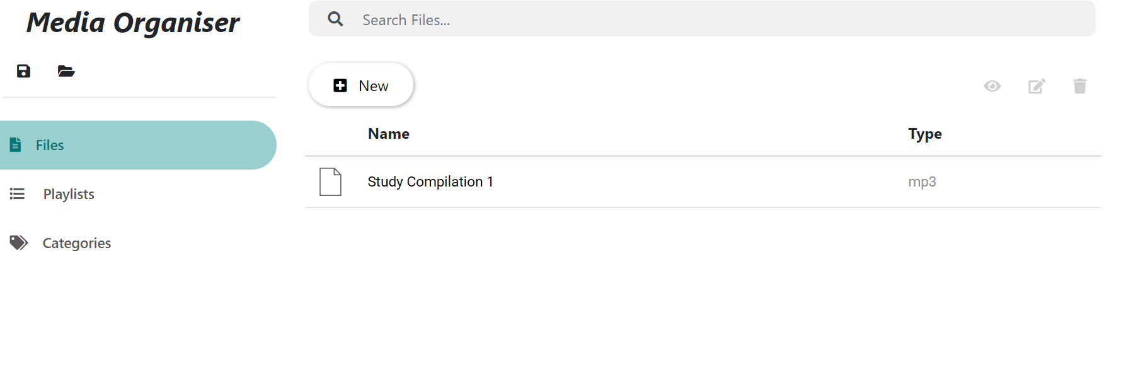

## Playlists

### Create Playlists

To create a playlist, go to the “Playlists” screen. This can be done by clicking on “Playlists” from the menu located on the left hand of the screen.



After landing on the playlist screen, you will see a small toolbar on top with multiple icons to perform different actions.

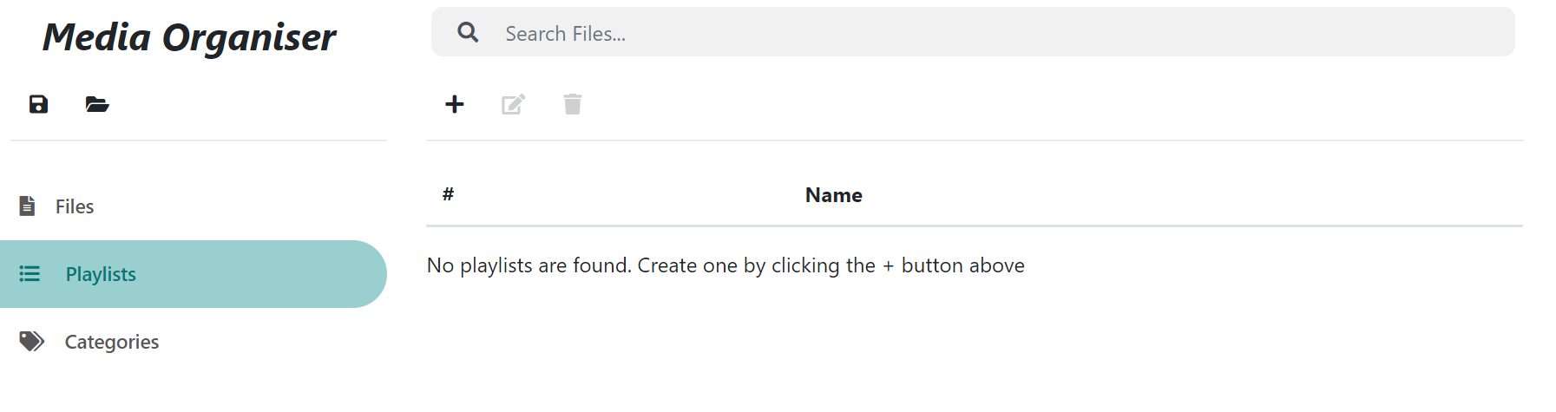

Click on the “+” icon. Clicking that will open a window and give you the ability to create a new playlist.

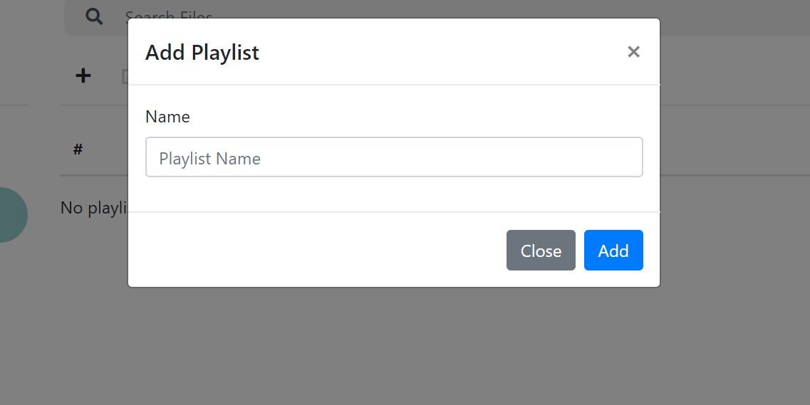

Enter your desired playlist name and click on “Add” button. This will close the window and create a new playlist in the system.

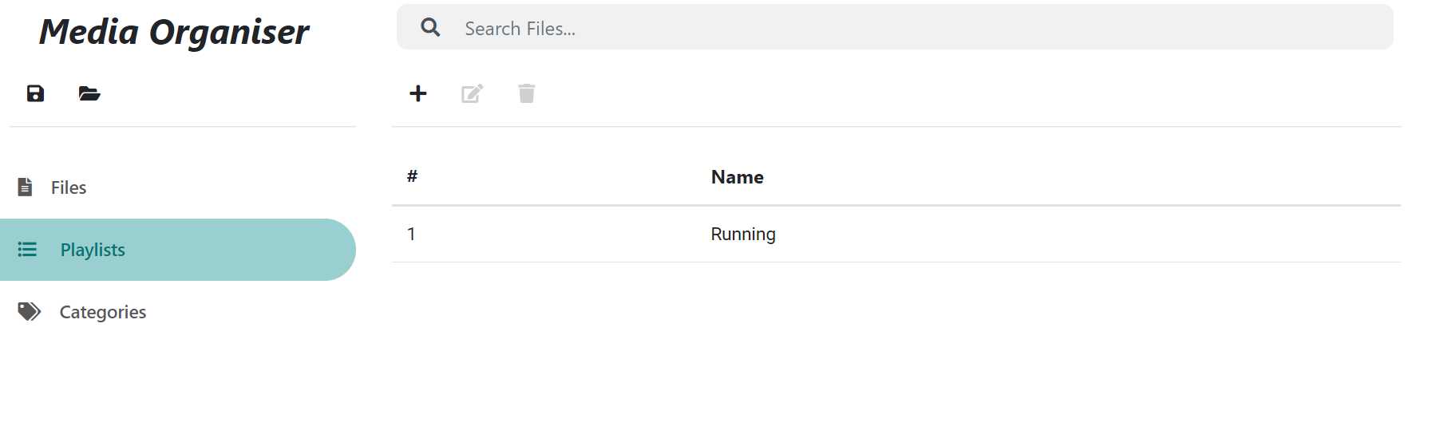

### Update Playlist Information

To update a playlist’s information, go to the “Playlists” screen. This can be done by clicking on “Playlists” from the menu located on the left hand of the screen.



After landing on the playlist screen, you will see a list of playlists in the already in the system. To edit any of the playlist’s information, click on one of the playlists you would like to edit.

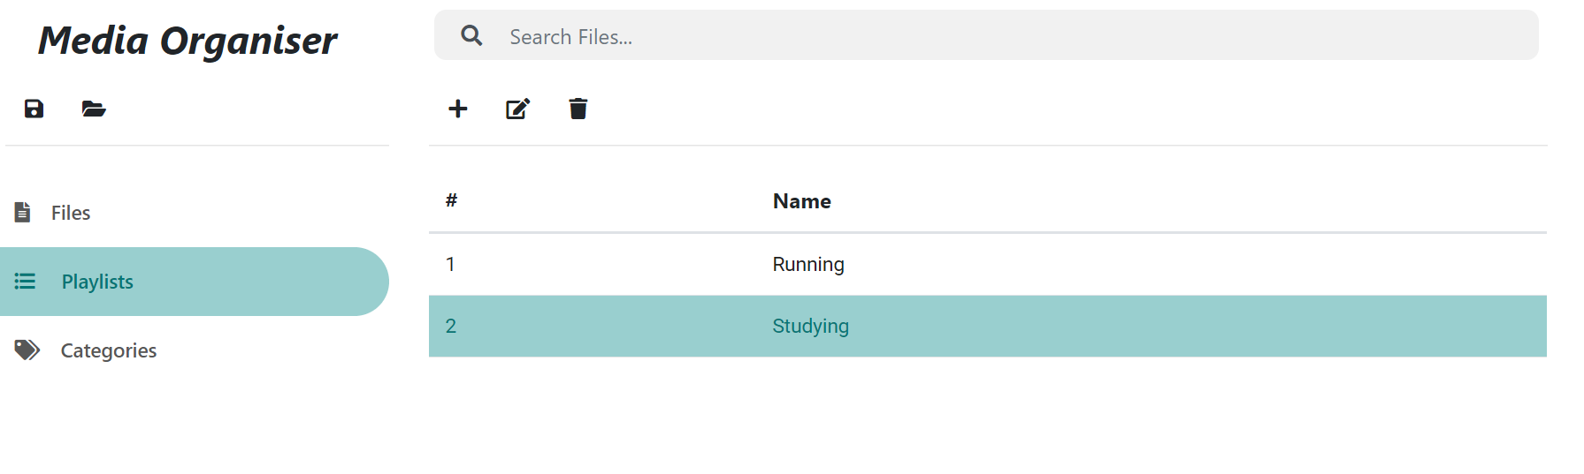

After clicking on the playlist, you will see some of the buttons on the toolbar getting enabled. Click on the “pencil” icon above to start editing the playlist information. After clicking on the “pencil” icon, a window will pop up giving you the ability to edit some information.

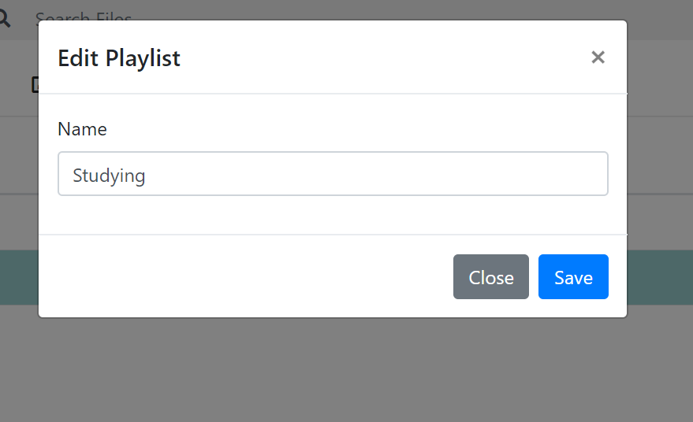

After editing the information about the playlist, click on “Save” to update the changes. The changes will be then reflected in the entire system.

### Manage Files in Playlist

To manage and reorder files in the playlist, go to the “Playlists” screen. This can be done by clicking on “Playlists” from the menu located on the left hand of the screen.



After landing on the playlist screen, you will see a list of playlists in the already in the system. To view the files of one of the playlists’, double click on one of the playlists. This will take you another screen which will show you all the media files associated with that playlist.

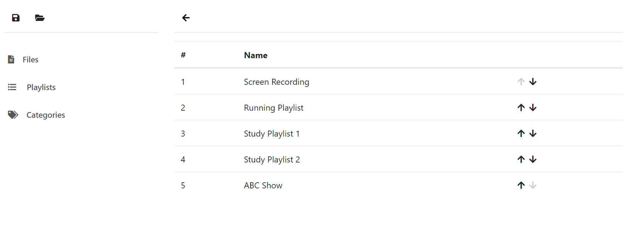

Here you can view all the files in the playlist and reorder files in the playlist. To reorder the file, click on the arrows on the right to move the file up or down. This order will be saved in the system automatically.

### Deleting Playlist

To delete the playlist, go to the “Playlists” screen. This can be done by clicking on “Playlists” from the menu located on the left hand of the screen.



After you’re on the “Playlists” screen, there will be a list of playlist which are already there in the system. To delete a playlist, click on one of the playlists that you would like to delete.

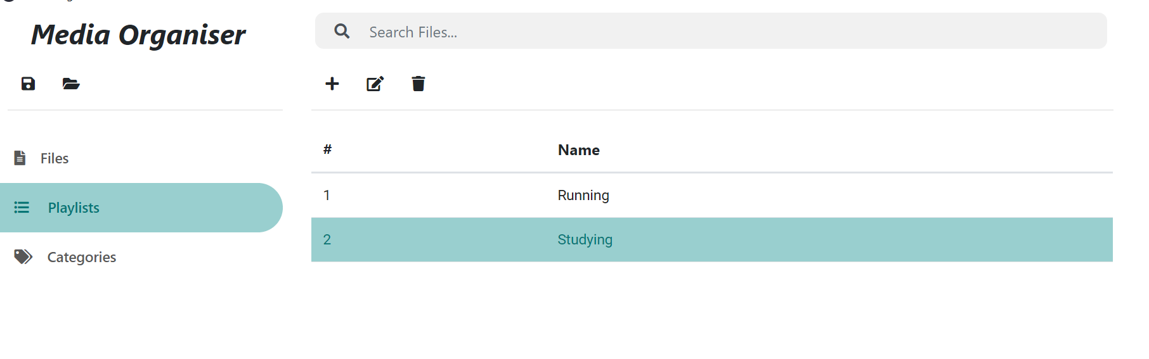

After clicking on the playlist, click on the “trash” icon on the toolbar. Clicking on that will immediately delete the playlist from the system.

## Categories

### Create categories

To create a category, go to the “Categories” screen. This can be done by clicking on “Categories” from the menu located on the left hand of the screen.



After landing on “Categories” page, you will see a small toolbar with multiple buttons to perform different actions

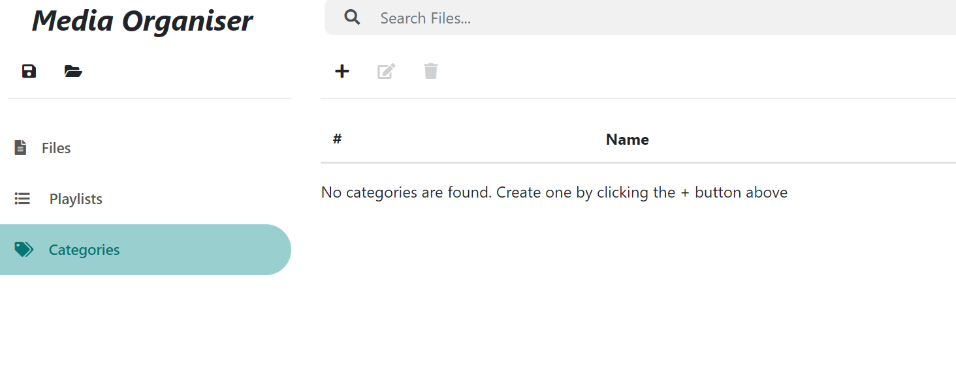

Click on the “+” button on the toolbar to add a new category. Clicking on that button will open a window on the screen giving you options before adding the category.

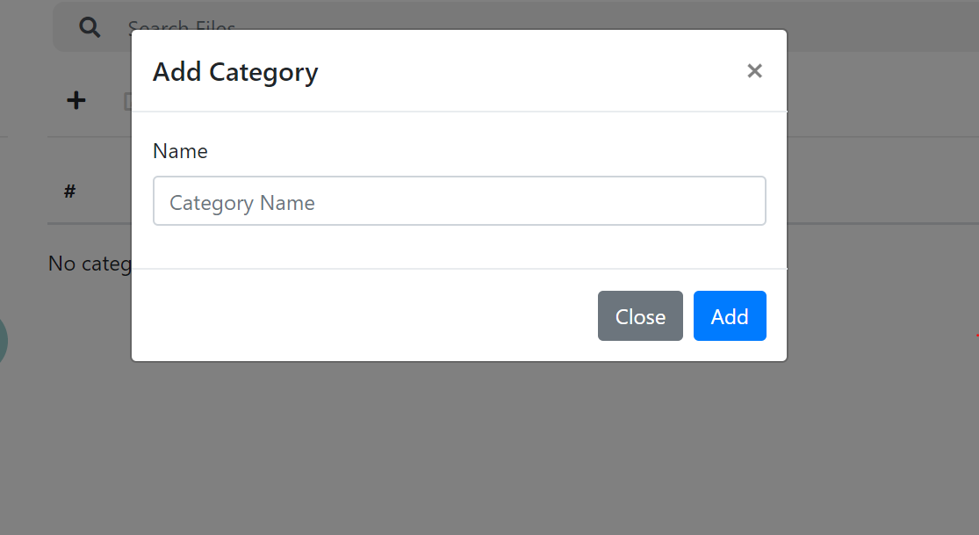

Enter the name of your desired category and click on “Add” button to create the category in the system.

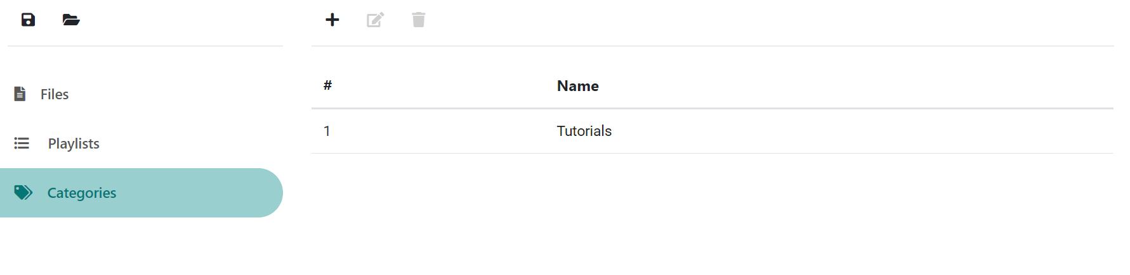

### Update category information

To update a category’s information, go to the “Categories” screen. This can be done by clicking on “Categories” from the menu located on the left hand of the screen.



After going on the “categories” screen, you will see a list of all the existing categories you’ve created previously.

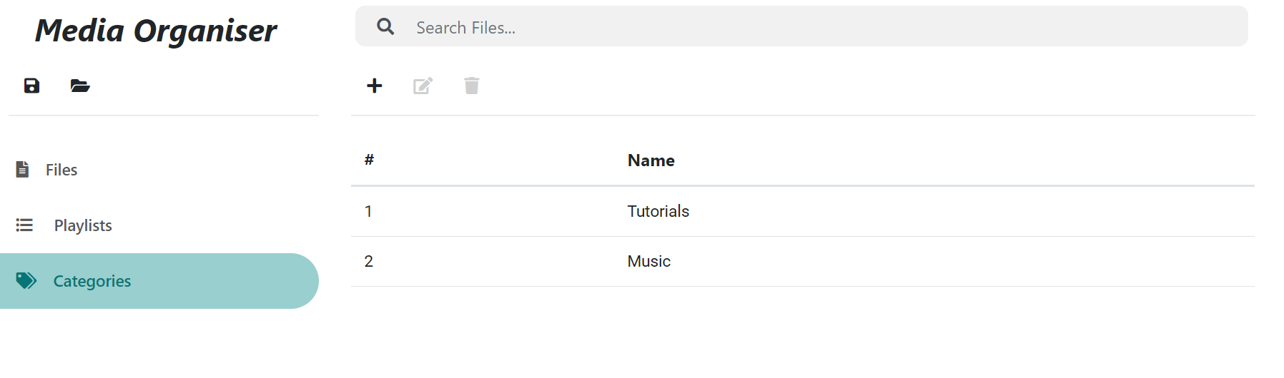

To edit information of any one of them, select the category you wish to edit by clicking on the category.

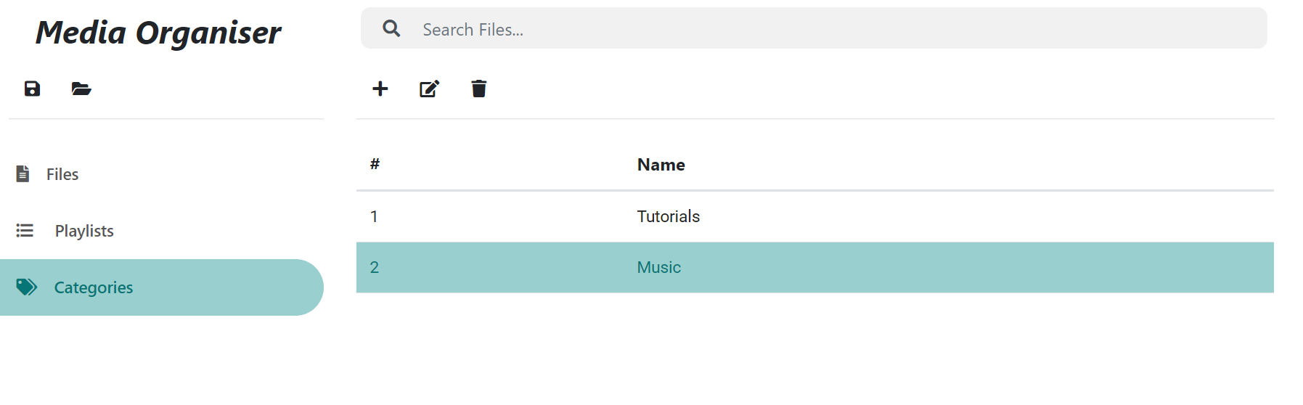

After selecting the category, click on the “pencil” icon on the toolbar above. Clicking on that icon will open a window on the screen giving you the ability to edit information of that category.

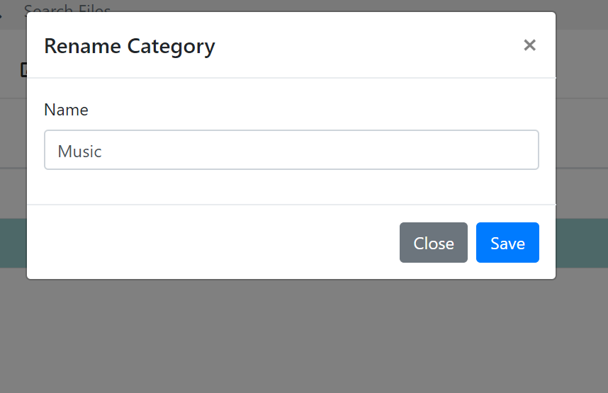

After editing the information for the category, click on “Save” button to save the changes and close the window.

### Delete category

To delete a category, go to the “Categories” screen. This can be done by clicking on “Categories” from the menu located on the left hand of the screen.



After going on the “Categories” screen, you will be able to see all the categories you’ve added previously. To delete a category, select one of the categories you wish to delete by clicking on the category.

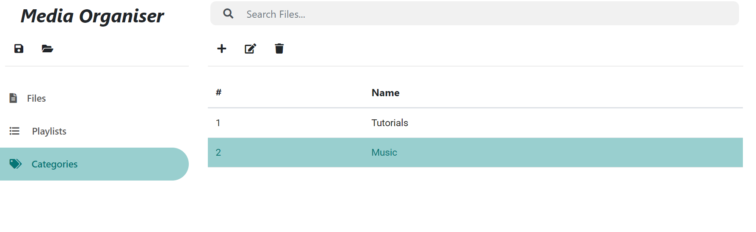

After selecting the category, you wish to delete, click on the “trash” button on the top toolbar. Clicking on that will immediately delete the category from the system.

## State management

### Saving current state

In order to persist the state of the application and data (i.e. files, playlists and categories), you will need to save the state on your local computer. The state is saved in a special “statefile” on the system.

To start the process of saving the state of the application, navigate to the application. You will find two buttons on the top left side of the screen.

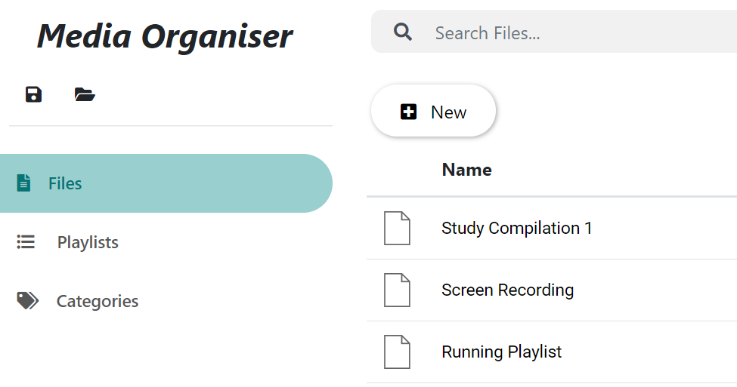

To save the state, click on the on the “floppy disk” button located on the left. This will open an explorer window which will allow you to select a destination for the state file to be saved in.

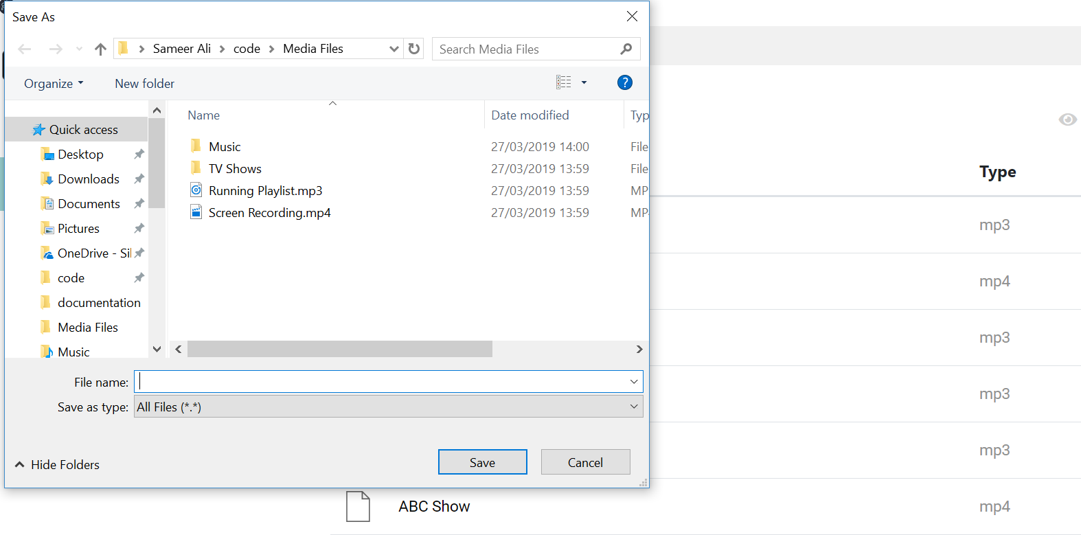

Enter the name of the file and click on “Save” to save the state of the file. The state will then be saved in your selected destination.

### Loading previous state

To start the process of loading a previously saved state of the application, navigate to the application. You will find two buttons on the top left side of the screen.



To load the state, click on the on the “folder” button located on the right of “floppy disk” button. This will open an explorer window which give you the option to locate a file with “.statefile” extension.

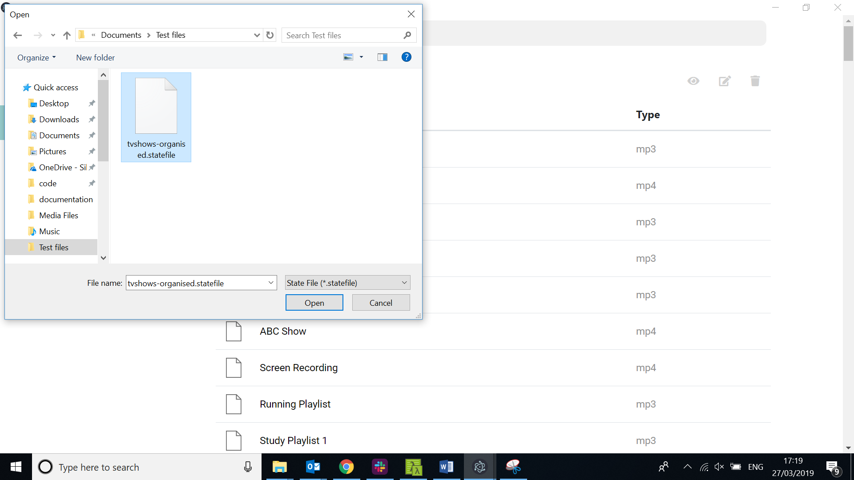

After selecting a statefile you’ve saved previously, click on “Open”. After clicking, go back to the application and you will see all the files, playlists and categories that you’ve saved in that state.

**Note:** This action will override your current state you’re working on. Please make sure to save the state before loading another state to avoid losing changed unexpectedly.